**DevOps for Devs – Assignment**

1. **Setting up a CI/CD Pipeline and deploying applications on AWS EKS**

**Step 1: Create a terraform file to provision and manage resources on AWS**

* Refer link : https://github.com/Chau-NH/sd4322_aws_infrastructure

**Step 2: Upload source code to GitHub**

* Source code for micro services: **frontend and backend**
  + https://github.com/Chau-NH/frontend
  + https://github.com/Chau-NH/backend
* Source code for Jenkins Pipeline**: jenkins-devops** (apply Shared Library)
  + https://github.com/Chau-NH/jenkins-devops

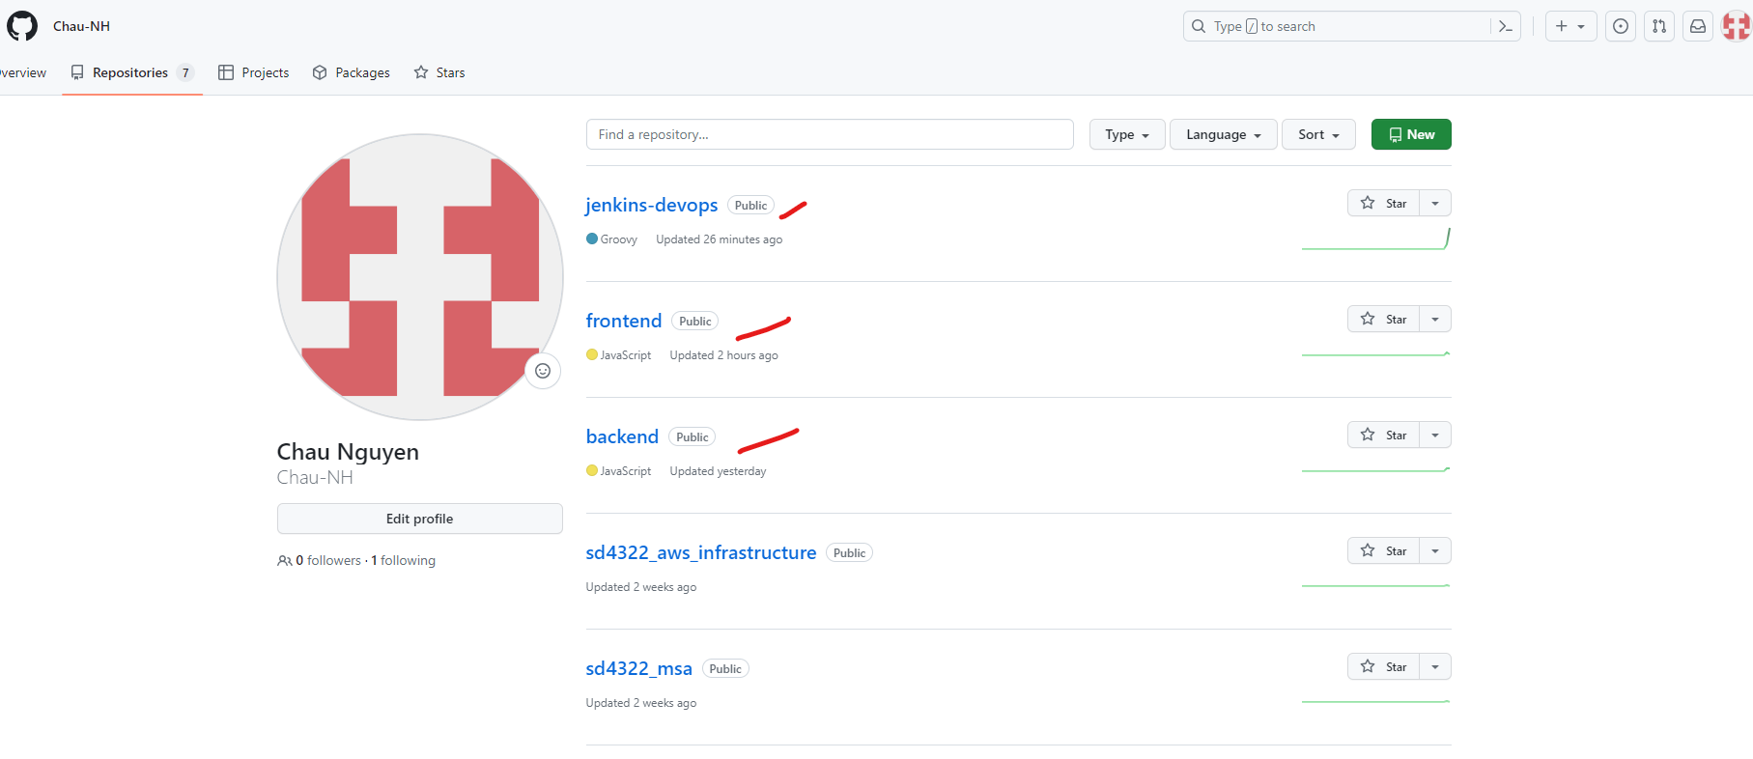

**Step 3: Install Jenkins server on EC2 and set up Shared Library**

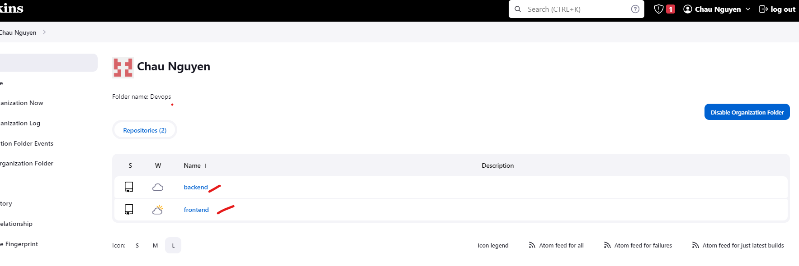

**Step 4: Build image to ECR and Deploy code to EKS using Jenkins Pipeline**

Run Jenkins Pipeline

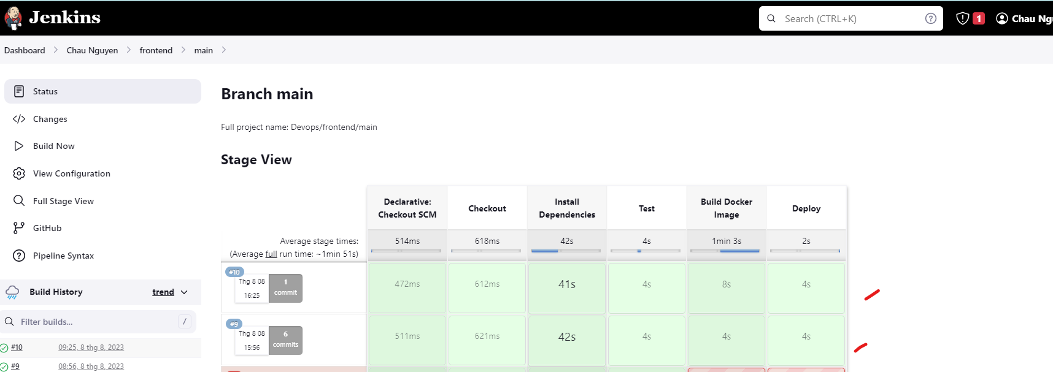

Check on ECR

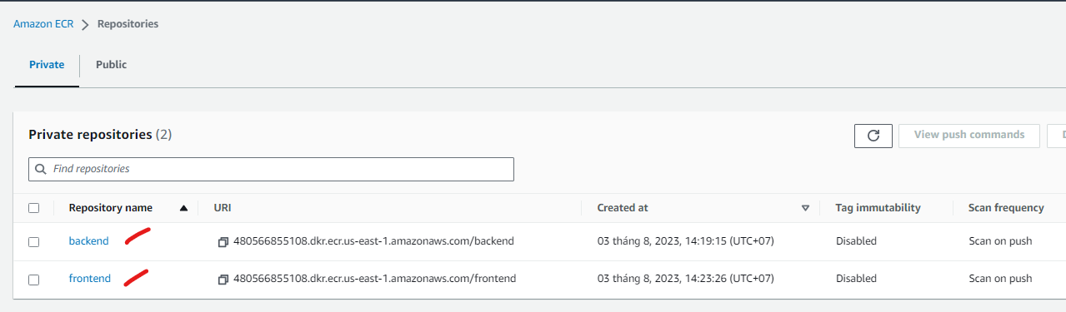

Check on EKS

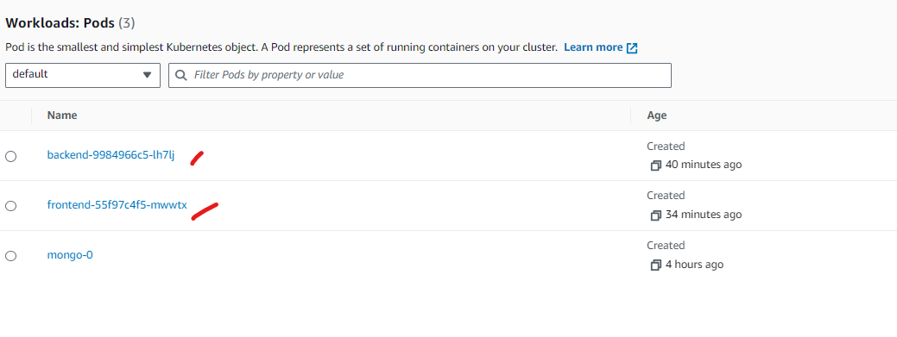

Check on browser

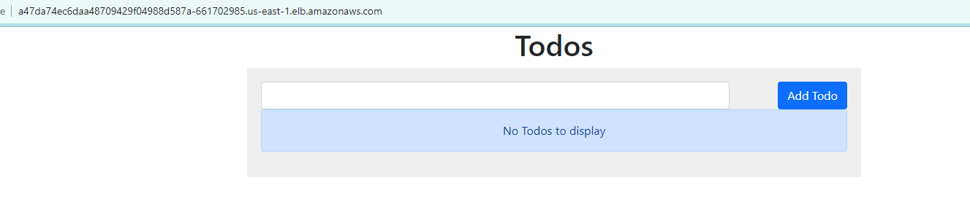

**Step 5: Change source code and rebuild Pipeline**

Change source and push to GIT repo

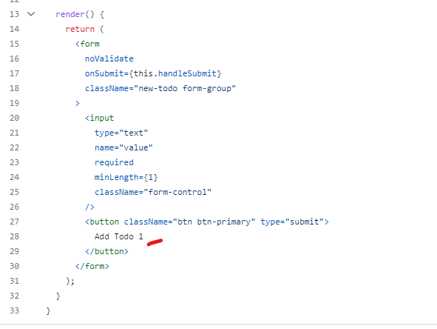

Check result after pipeline running

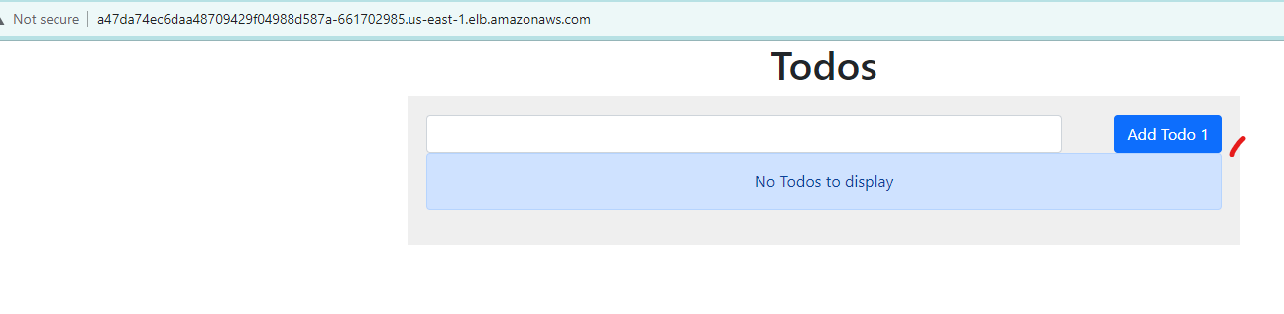

**Step 6: Set up Prometheus and Grafana to monitor EKS resources and default EKS resource metric**

Check on terminal

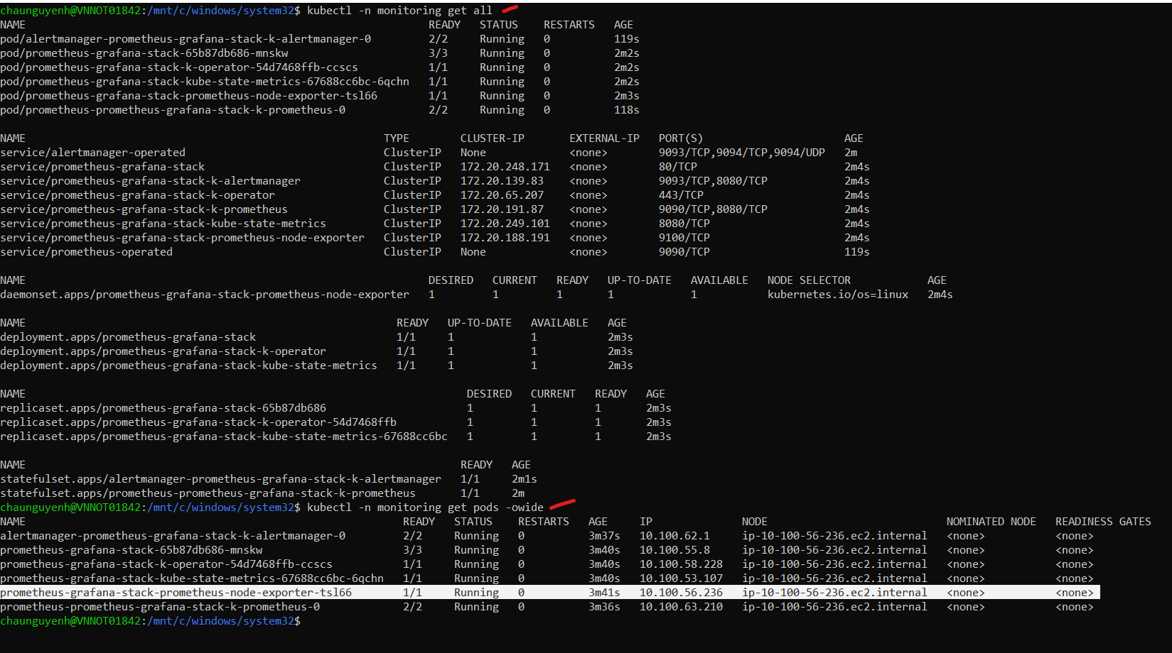

Check on EKS cluster

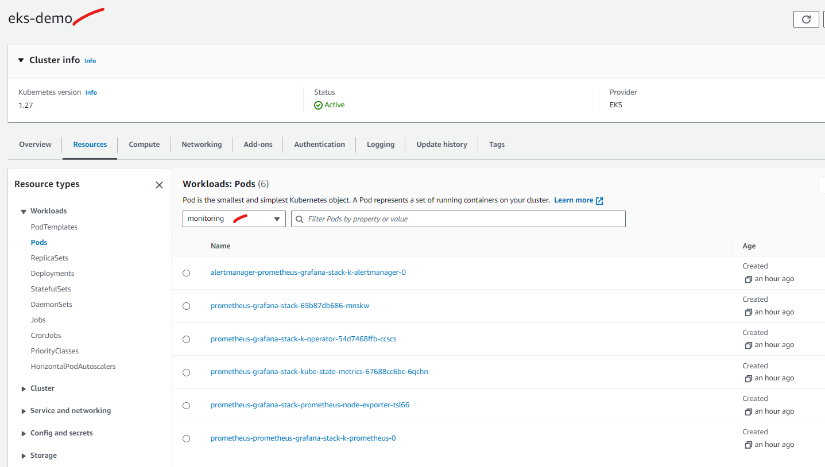

Access Grafana on UI

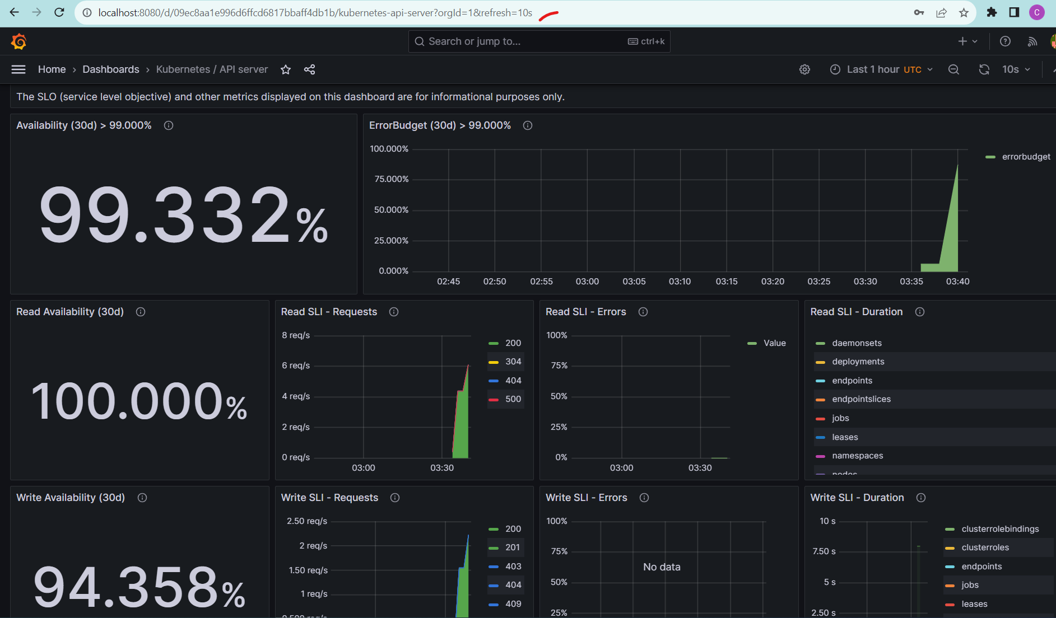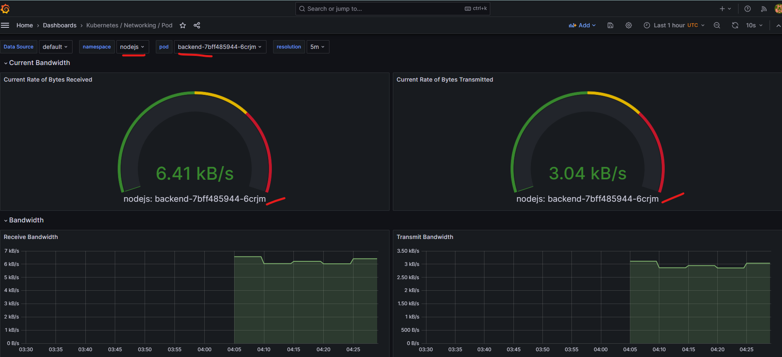

Deploy monitoring on backend service

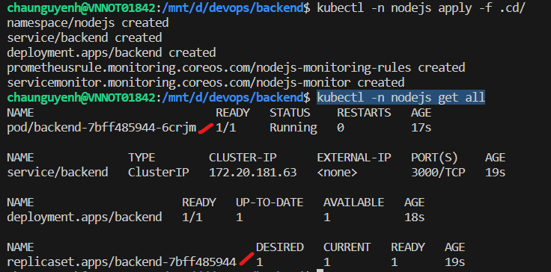

Access Prometheus on UI

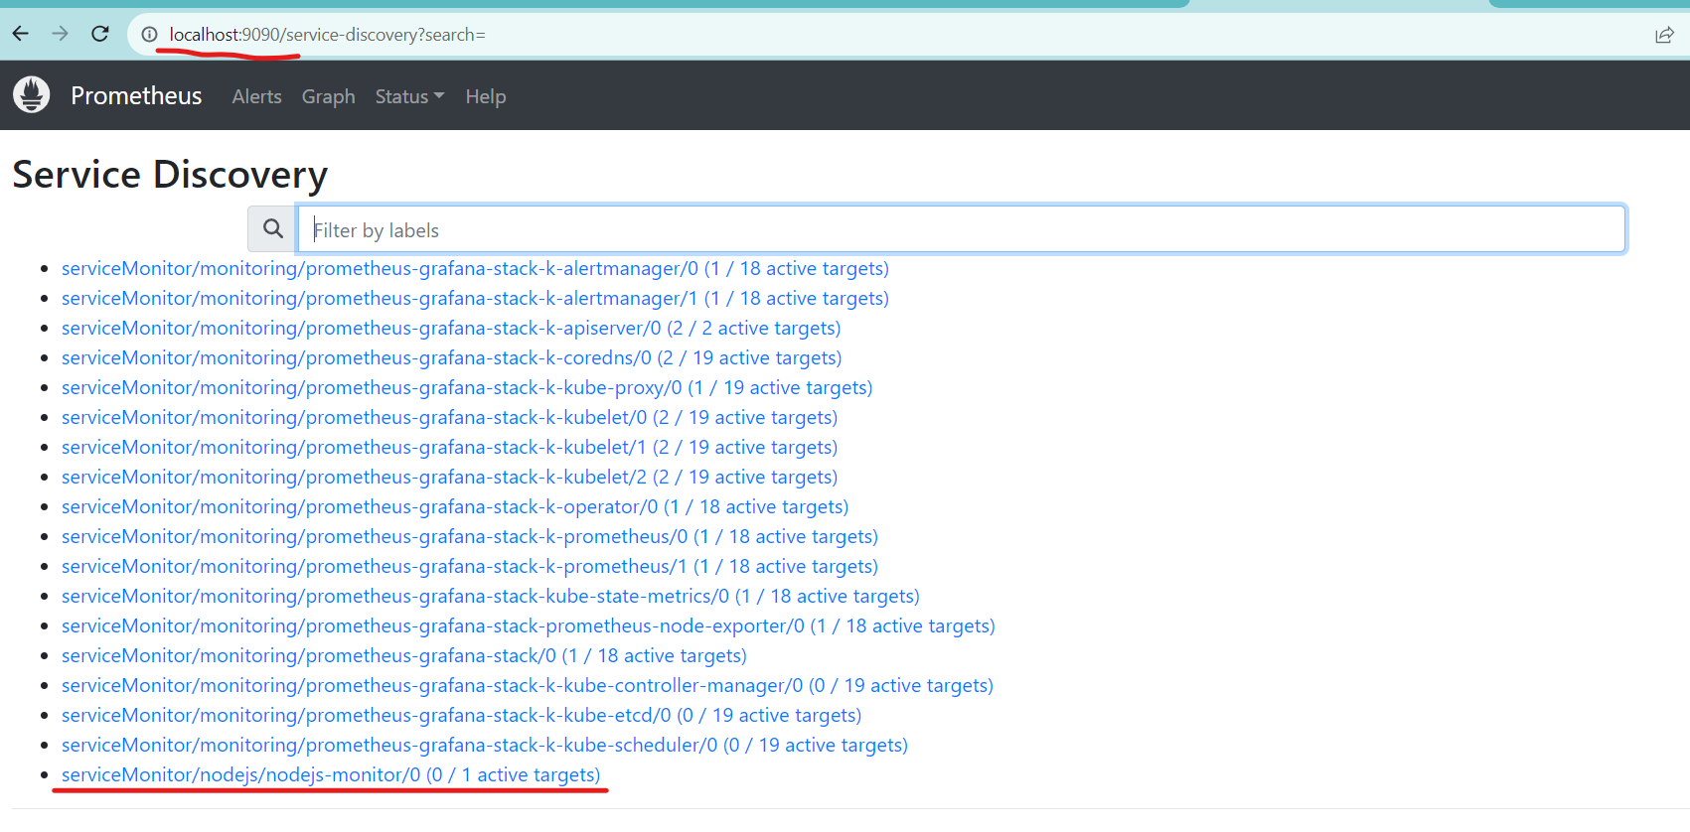

1. **Reuse Jenkins CI and use GitOps for the CD pipeline.**

Step 1: Install ArgoCD on Cluster

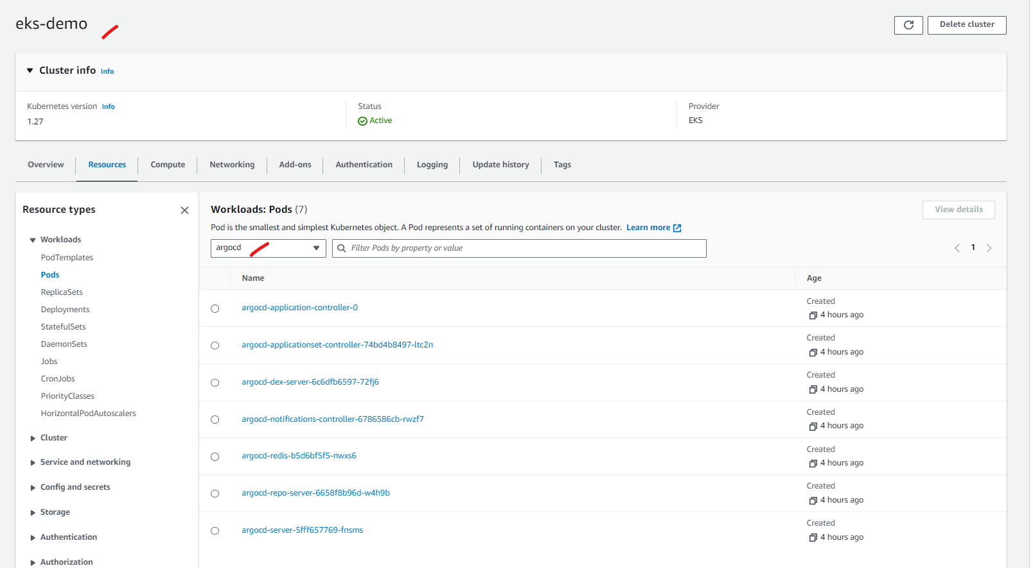

Step 2: Go to UI and set up for micro services

